Dreadnought education plan

Topic:
Transport problem in Hong Kong
Learning objective:
- Understand transport problem in Hong Kong
- Relationship between citizen behavior & transport problem
- Policy of transport in HK
- Leisure life style and transportation (cycling path, jogging path)
- Innovation of transportation system
- STEM training
- Design Project of Hong Kong transport problem
Learning outcome:
- Citizen responsibility
- Creativity in problem solving
- Design thinking
- Peer-to-peer learning
- Fundamental of Electric Vehicle Technology
- Skill in prototype building (3D design, electronics & mechanical skill)
Class schedule:
- 5 class for topic discussion (bi-weekly)
- Coverage of Social Science, Science Theory, Current Technology
- Involved learning kit
- 5 self-training class for stem
- Student need to show their innovation in the design of EV chassis & decoration

Details class plan:

Learning objective | class | Topic | Coverage | Time
Introduction of daily transport problem | 1 (why transportation is crucial for citizen daily life?) | Managing daily activities | Healthy lifestyle  Facilities for leisure transportation  Work-life balance | 10 mins
 |  | Social interaction | Understand transport problem in Hong Kong  Social movement  Electric vehicle  Shortage of Hong Kong current policy to transportation issue | 20 mins
 |  | Competence for the world of work | Team building workshop  Brainstorming about transportation facilities surround the school  How do student improve the facility | 30 mins
Transportation, Hong Kong Economics & city planning | 2 (why transportation is a crucial social problem to Hong Kong?) | Competence for the world of work | International status of Hong Kong  Business type that highly related to transportation  Massive transportation system | 10 mins
 |  | Entrepreneurship & Technology | Payoff of Hong Kong transportation (air pollution, waste heat, etc.)  Discussion of previous action shortage  Innovation of transportation business | 20 mins
 |  | STEM education | Experience workshop – the Chassis building of an EV | 30 mins
Facilities, import & export | 3 | Social interaction | Facilities & policy for export & import in Hong Kong  Mechanism, function and GDP of each facility | 10 mins
 |  | Entrepreneurship & Technology | Foreign example in trading transportation  Extreme transportation  Innovation of trading transportation  Discussion of previous action shortage | 20 mins
 |  | STEM education | Experience workshop – the drivetrain system building of an EV | 30 mins
Transport management | 4(how to build a sustainable system to solve transport problem?) | Social interaction | City planning  Road monitoring management  AI driving  Alternative transportation | 10 mins
 |  | Entrepreneurship & Technology | Foreign example in innovative transportation  Discussion of previous action shortage | 20 mins
 |  | STEM education | Experience workshop – the control system building of an EV | 30 mins

Experience Workshop
Product:
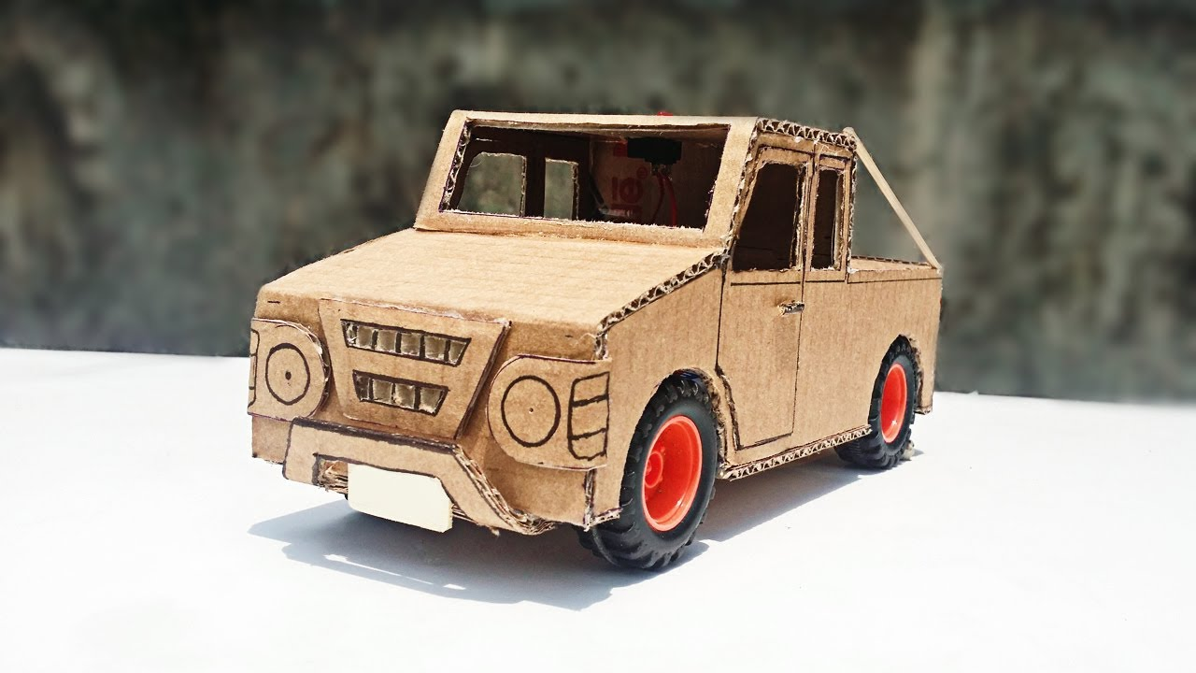
Example of Electric Vehicle that build in the workshop

